Windows Event Forwarding/Windows Event Collector & Sysmon Guide
Created By: Cpl Freeman, Lucas and Cpl Barker, Robert P 20211014
Edited By: Cpl Freeman, Lucas 20211208

Introduction

To have a successful centralized collection of logs with the use of Windows Event Forwarding (WEF) to a Windows Event Collector (WEC) with Windows and Sysmon logs the following 4 steps should be taken in this order.

1.) Deploy Sysmon64.exe to all systems
2.) Enable WinRM on all systems
3.) Set up WEC
4.) Set up WEF

Logical Flow of Logs

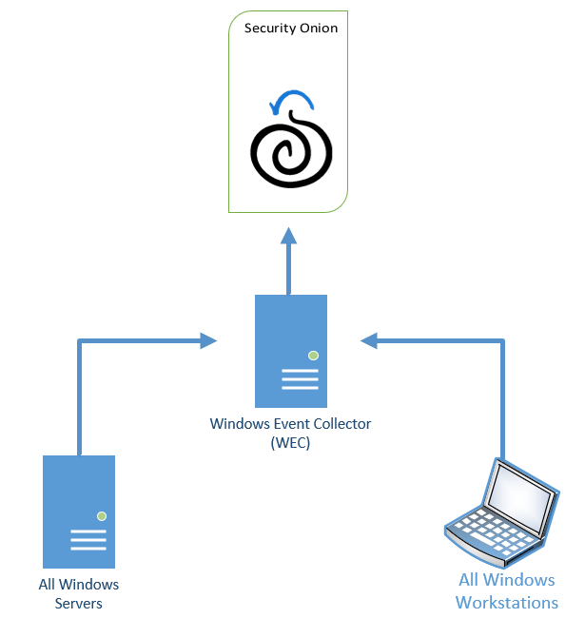

Deploy Sysmon64 to all Systems

The purpose of deploying Sysmon64 first to all windows systems is to start the collection of logs local to the windows systems while the rest of the steps and troubleshooting takes place. Having logs local to the systems is better then having no logs at all in the worst case a Cyber incident occurs.

Step 1.)
Open SysmonScript.ps1 with your favorite script editor (Notepad++, Powershell ISE, ect…)

#### Quick Notes #####
If you do not have the shop’s sysmon script, just google how to install symon and build a script around it. You can make a basic script in like 5 minutes. Also, the configuration file we use is from SwiftOnSecurity github page.

Step 2.)
Upload the SysmonScript.ps1, Sysmon64.exe, and symonconfig-export.xml to a share that all systems can reach. If no share is available you can use the Domain Controller’s SYSVOL folder.

Step 3.)
Edit the variables to have the proper path to your Sysmon64.exe and configuration file. Picture shown below of what it should look similar too.

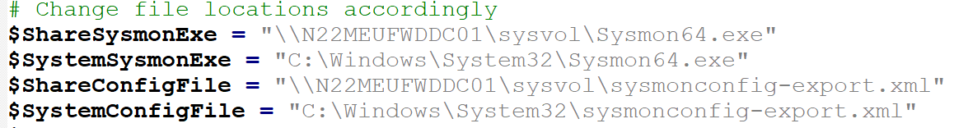

Step 4.)
Create a scheduled task in a Group Policy object (GPO)

From the menu tree, Computer Configuration -> Preferences -> Control Panel -> Scheduled tasks, right click and create New → Scheduled Task (At Least Windows 7)

Build your task based off your needs or requirements. This is how ours look
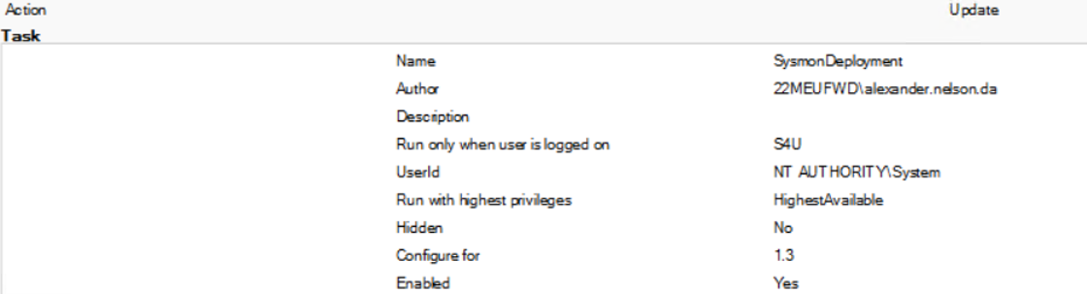

Triggers:

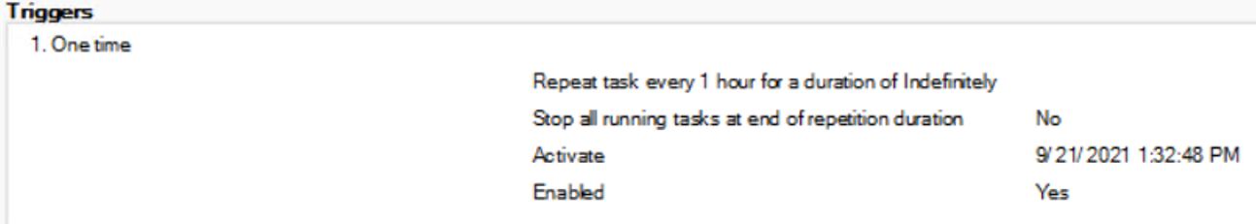

Actions:
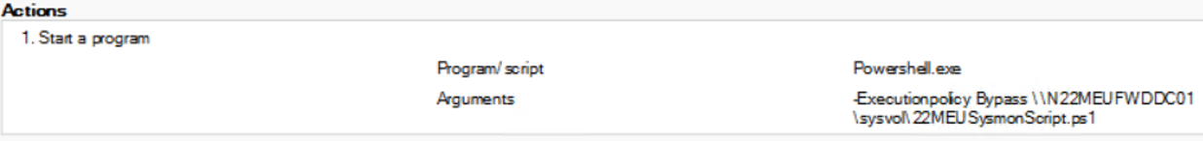

Settings:
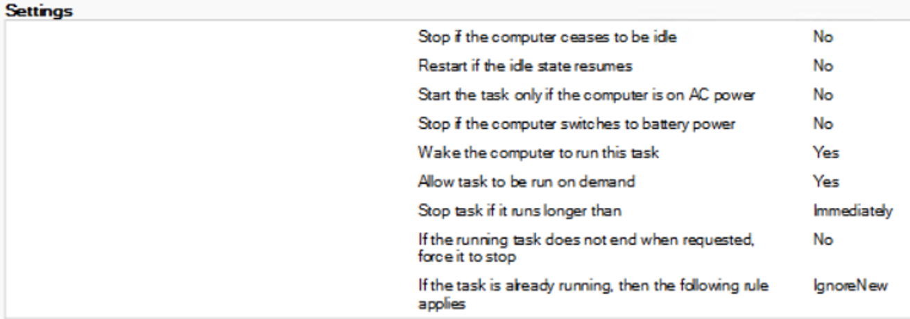
Step 5.)
Link the GPO to the site.

##### Quick Notes ######
To verify your GPO works, from an elevated cmd prompt run gpupdate /force
Then open ‘Task Scheduler’ and see if the scheduled task propagated to the endpoint machine. If it did click on it and select ‘Run’. After the task is finished running check your services and see if sysmon* is running.

Enable WinRM On All Systems

WinRM is used for many remote management features such as WEF, and PSSessions. For WEF to work a base install and configuration of WinRM will be first need to be done. The enabling of WinRM is best done by a GPO that has two main parts.

Step 1.)
Create a new GPO
Enable WinRM service
Computer config > policies > Preferences > Control Panel Settings > Services

Add New Service

Startup "Automatic (Delayed Start)"

Service name "WinRM"

Service action: Start Service

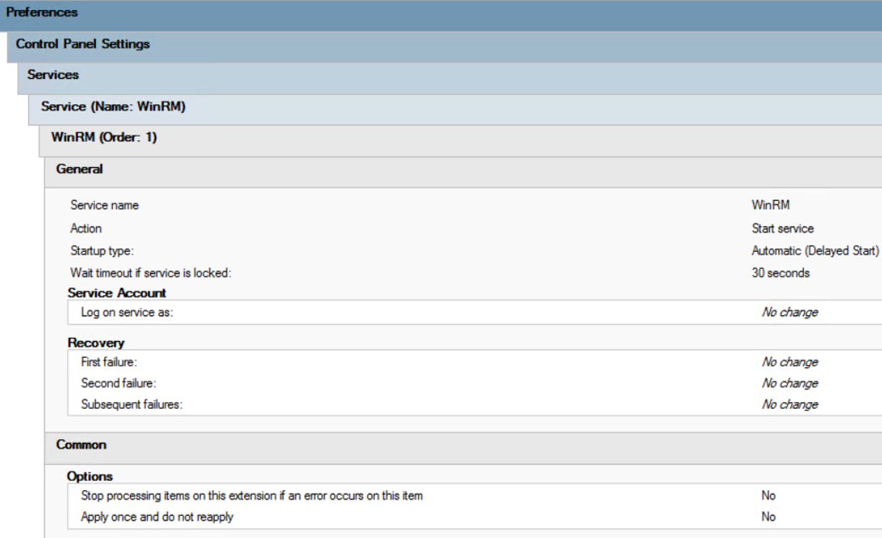

Step 2.)
Add a firewall rule to allow WinRM
Computer Configuration > Policies > Windows Settings > Security Settings > Windows Firewall with Advanced Security > Inbound Rule

Add New Rule

Select Predefined, add "Windows Remote Management", Select Next

Uncheck Public Profile, Select Next

Allow the connection, Select Next

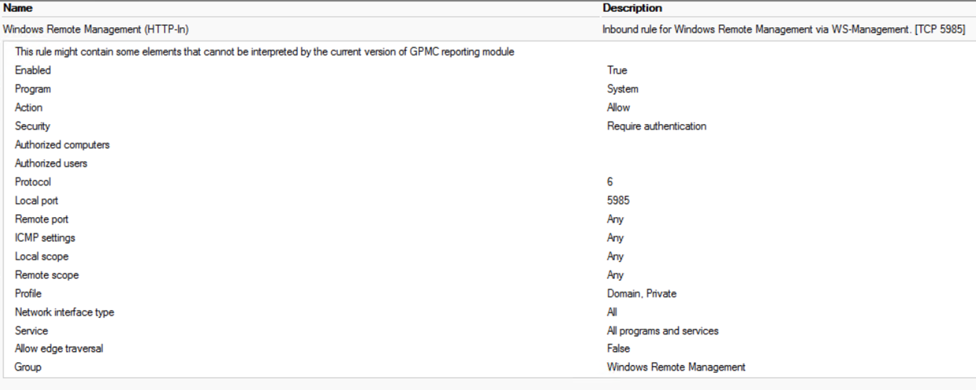

Step 3.)
Apply the GPO to cover the Windows systems.

Set Up WEC

A centralized location of logs makes it easy to manage and parse information in case of a Cyber incident. Windows offers a free method to do so, which we will set up in this part. It is best practice to select a windows server to be the centralized log system, however any Windows system can be utilized as a WEC.

Step 1.)
From an elevated command prompt run the following commands:

“winrm qc”
“wecutil qc”

Take note of this information you will need to reference it when creating a WEF GPO

You will need to navigate to Event Viewer then subscriptions and create subscriptions based off what you are logging for and how quickly you wish the logs to be shipped.

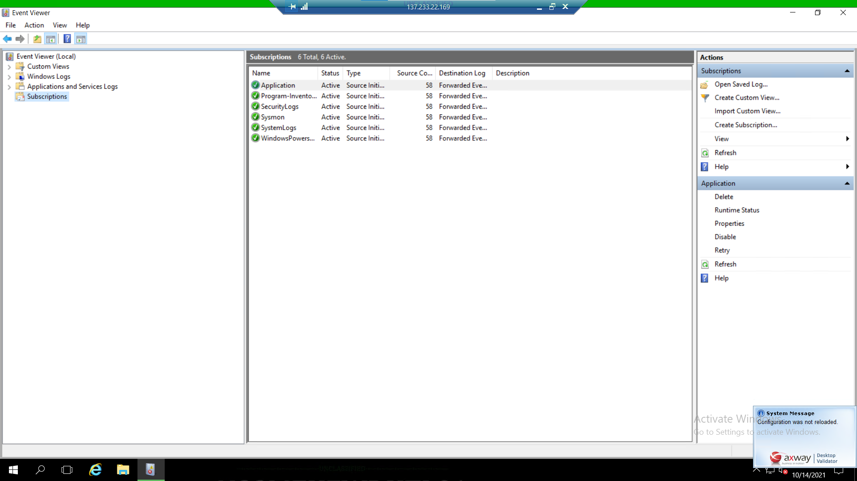

Set up WEF

Setting up WEF is bast done though a GPO, The GPO is quite lengthy so attention to detail is vital in this last and final part.

Allow remote server management through WinRM
- Create a new GPO for Windows Event Forwarding
- From the menu tree, click Computer Configuration > Policies > Administrative Templates: Policy definitions > Windows Components > Windows Remote Management (WinRM) > WinRM Service.
- Right-click on Allow remote server management through WinRM and click Edit.
- Select Enabled to allow remote server management through WinRM.
- Enter an asterisk (*) into each field.
- Click OK.

Add "Network Service" to the "Event Log Readers" restricted group
- From the menu tree, click Computer Configuration > Policies > Windows Settings > Security Settings > Restricted Groups
- Right Click, add Event Log Readers
- Right Click on Event Log Readers and add Network Service into members of this group

Tell the computers to subscribe to the WEC
- From the menu tree, click Computer Configuration > Policies > Administrative Templates: Policy definitions > Windows Components > Event Forwarding > Configure target Subscription Manager
- Right click Edit
- Add in your Subscription Managers should look like this “Server=http://<FQDN>:5985/wsman/SubscriptionManager/WEC,Refresh=60”
- Click the Enable button , hit OK

Append (A;;0x1;;;NS) to the Security Descriptor Definition Language (SDDL)

- On your WEC open an elevated Command Prompt
- Run wevtutil gl security
- Copy the value for channelaccess to notepad
- Append (A;;0x1;;;NS) to the SDDL
- Should look like this O:BAG:SYD:(A;;0xf0005;;;SY)(A;;0x5;;;BA)(A;;0x1;;;S-1-5-32-573)(A;;0x1;;;NS)
- Back in your GPO. from the menu tree, click Computer Configuration > Polices > Administrative Templates: policy definitions > Windows Components > Event Log Service > Security > Configure log access
- Add O:BAG:SYD:(A;;0xf0005;;;SY)(A;;0x5;;;BA)(A;;0x1;;;S-1-5-32-573)(A;;0x1;;;NS) into log access
- Link your GPO

##### Quick Notes ######
In order for WEF to work, WINRM must be running on all endpoint devices. Windows servers have this done automatically, but regular window installations do not. If the domain admins did not already start WINRM throughout the network you’ll have to build a GPO for that as well.

